# Project Mission Statement

Cirno Team will develop a parking app, ParkWhere, to allow motorists to look up carpark information. The project is complete when the app is tested and approved by the ZEA (CZ2006/CE2006 Authority). This project supports the Data-Driven Smart Nation Competition to exploit publicly available government data to help motorists find suitable carparks easily.

# Functional Requirements

1. Main Menu
   1. User must be able to input a search query into the main search bar.
   2. When the user taps the “Search” button, the system must parse the user’s search query and conduct a search based on that query.
      1. The system must be able to parse the user’s search query into a search type. Search types include:
         1. Full address
         2. Partial address (only road name or general location)
         3. Postal Code
         4. Carpark number
      2. The system must be able to conduct a search based on a search query.
         1. The search query will be listed on the Search Listing page.
2. Search Listing
   1. The system must display the resolved search query on the Search Listing page.
   2. The system must display, in pages, the nearest carparks to the searched location in the order of closest to furthest.
   3. The system must display at most 10 carpark listings per page in a table format.
      1. In each row of the table, the system must display each carpark listing’s Basic Information.
         1. The system must show the carpark listing as greyed out if the carpark’s available lots is zero.
      2. When the user taps a carpark listing, the system must show that carpark’s Advanced Information.
      3. When the user taps a carpark listing, the user must be able to add or remove that carpark to their Favorites list.
   4. When the user taps the “Next Page” button, the system shows the next 10 carpark listings in order.
   5. The system must be able to filter search results returned from a search query.
   6. When the user taps the “Filter” button, the system must show the filtering options. The filtering options are:
      1. Maximum distance to carpark
      2. Minimum number of available lots
      3. Parking System (Electronic/Coupon)
      4. Short Term Parking availability
      5. Free Parking availability
      6. Night Parking availability
   7. When any of the search filters are applied, the system must repopulate the search listing with carparks that meet the search filters’ criteria.
3. Favorites Listing
   1. The user must be able to add and remove carparks to a Favorites list. (see 2.3.3)
   2. The system must display, in pages, the Favorite carparks in alphabetical order of carpark number.
   3. The system must display at most 10 carpark listings per page in a table format.
      1. In each row of the table, the system must display each carpark listing’s Basic Information.
         1. The system must show the carpark listing as greyed out if the carpark’s available lots is zero.
      2. When the user taps a carpark listing, the system must show that carpark’s Advanced Information.
      3. When the user taps a carpark listing, the user must be able to add or remove that carpark to their Favorites list.
   4. When the user taps the “Next Page” button, the system shows the next 10 carpark listings in order.
4. Blacklist
   1. The user must be able to add and remove carparks to a Blacklist. (see 2.3.3)
   2. The system must display, in pages, the Blacklisted carparks in alphabetical order of carpark number.
   3. The system must display at most 10 carpark listings per page in a table format.
      1. In each row of the table, the system must display each carpark listing’s Basic Information.
         1. The system must show the carpark listing as greyed out if the carpark’s available lots is zero.
      2. When the user taps a carpark listing, the system must show that carpark’s Advanced Information.
      3. When the user taps a carpark listing, the user must be able to add or remove that carpark to their Blacklist.
   4. When the user taps the “Next Page” button, the system shows the next 10 carpark listings in order.
5. Map
   1. When the user requests a map of nearby carparks, the system must show a map with markers indicating the 10 nearest carparks to the user’s current location.
      1. The map’s zoom level must be at the finest level appropriate that shows all 10 nearest carparks.
         1. If the user zooms out from default zoom level shown, carparks other than the specified 10 carparks must be shown as markers on the map.
      2. When the user taps on a marker for a carpark, an info box must be shown by the system. This info box should contain:
         1. Carpark number
         2. Available lots
         3. Total lots
         4. A button to request navigation to this carpark
   2. From a specific carpark’s Advanced Information screen, or a specific carpark selected in the map described in 5.1, the user must be able to request navigation to this carpark. Upon requesting navigation, the system must find the fastest route from the user’s current location to the location of the specified carpark.
      1. The system must show on a map a highlighted fastest route between the user’s current location and the location of the requested carpark.
6. Graph
   1. The user must be able to query the graph of a certain carpark.
   2. The system must show the graph of the availability history of that carpark.
      1. The system must retrieve the data from the history database.
      2. The history database must give the last 24 hours of history of the requested carpark
   3. The system must show the trending hour graph of that carpark
      1. The system must show the graph of the trend of the carpark

# Non-Functional Requirements

1. System must not crash.
2. System must not hang.
3. Search must return result within 5 seconds.
4. 90% of users must be able to get the search results within 2 minutes upon accessing the system.

# Data Dictionary

Carpark – A building or infrastructure that allows cars to be parked legally.

Carpark Number – The unique alpha-numeric identifier for a singular carpark.

Carpark Location – The details of where the carpark is located. This may include street name, block number, postal code.

Carpark Lots – Individual spaces for a single car to be parked.

Available Lots in Carpark – The current number of carpark lots that are not occupied by a parked car.

Total Lots in Carpark – The maximum number of carpark lots that a carpark accommodates.

Carpark Basic Information – A collection of basic information about a carpark, that is displayed in the Search Listing. This includes: Carpark Number, Carpark Distance from queried location, Carpark Location, Available Lots in Carpark, Total Lots in Carpark

Carpark Advanced Information – A collection of advanced information about a carpark, that is displayed when the user selects a carpark. This includes: Carpark Rates, Parking System (Electronic/Coupon), Short Term Parking Times, Free Parking Availability, Night Parking Availability, HDB/URA/LTA affiliation

# Use Case Diagram

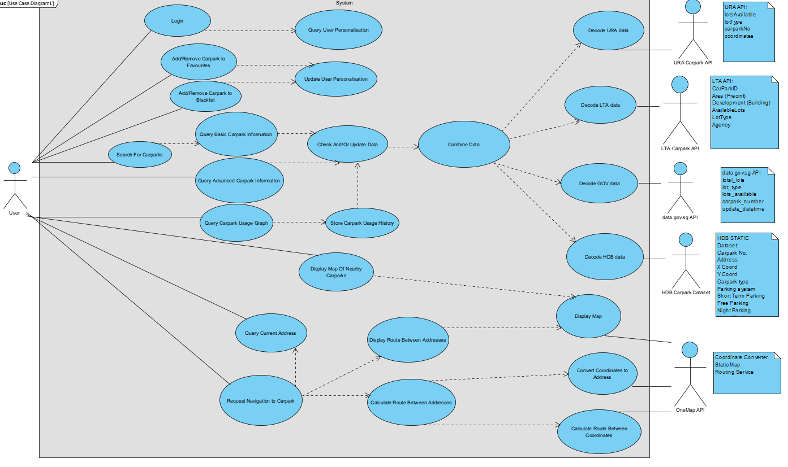

# Class Diagram

# Use Case Description

|  |  |  |  |
| --- | --- | --- | --- |
| Use Case ID: | 1 | | |
| Use Case Name: | Search For Carparks | | |
| Created By: | Tan Chuan Liang | Last Updated By: | Tan Chuan Liang |
| Date Created: | 1/28/2023 | Date Last Updated: | 8/2/2023 |
| Actor: | User (Initiating Actor) | | |
| Description: | Search for nearby carparks based on search query. | | |
| Preconditions: | 1. App must be connected to WiFi/Mobile Data | | |
| Postconditions: | 1. User is able to view a list of nearby carparks | | |
| Priority: | High | | |
| Frequency of Use: | 0-10 times per day | | |
| Flow of Events: | 1. User enters search query into search bar 2. System parses search query into a resolvable location 3. System finds at most 10 (or other preset value) nearest carparks to the queried location 4. System displays at most 10 (or other preset value) nearest carparks to the queried location, with each carpark’s Basic Information, using the included use case Query Basic Carpark Information | | |
| Alternative Flows: | AF-S1: User taps “Back” button while system is searching.   1. Return to step 1.   AF-S2a: User does not enter search query into search bar and commences search.   1. System assumes queried location to be current location.   AF-S2b: Search query cannot be resolved to a location.   1. System assumes queried location to be current location.   AF-S4: User taps “Next Page” button   1. If there are more carpark listings, system repopulates search listing with next 10 (or other preset value) carpark listings, continue from step 3.   AF-S4: User taps “Previous Page” button   1. System repopulates search listing with previous 10 (or other preset value) carpark listings, continue from step 3. | | |
| Exceptions: | EX-AF-S2a/b: Current location cannot be determined   1. System displays error message “Cannot find current location, please allow and turn on GPS”   EX-AF-S2: Internet connection gets cut off   1. System displays error message “No internet connection, please check if your mobile data or Wifi is turned on.” 2. Return to step 1. | | |
| Includes: | #2 Query Basic Carpark Information  #3 Query Advanced Carpark Information | | |
| Special Requirements: | - | | |
| Assumptions: | 1. Real-time Basic Information for found carparks is retrieved successfully. | | |
| Notes and Issues: | - | | |

|  |  |  |  |
| --- | --- | --- | --- |
| Use Case ID: | 2 | | |
| Use Case Name: | Query Basic Carpark Information | | |
| Created By: | Tan Chuan Liang | Last Updated By: | Tan Chuan Liang |
| Date Created: | 1/28/2023 | Date Last Updated: | 8/2/2023 |
| Actor: | User (Initiating Actor) | | |
| Description: | Query basic carpark information from stored carpark data | | |
| Preconditions: | 1. Request is made for basic information of a list of carparks | | |
| Postconditions: | 1. Basic information of a list of carparks is returned | | |
| Priority: | High | | |
| Frequency of Use: | 0-10 times per day | | |
| Flow of Events: | 1. Use Case #1 “Search for Carparks” requests the basic information of a list of carparks. 2. System must find the data of the list of carparks given using Use Case #4 “Check And/Or Update Data”. 3. System must extract the basic information of each carpark given. 4. System returns the basic carpark information of the list of carparks given. | | |
| Alternative Flows: | - | | |
| Exceptions: | EX-2: Basic data of at least 1 carpark not returned by Use Case #4 “Check And/Or Update Data”   1. System displays error message “Carpark data not complete, some fields may be blank”. 2. Return null values for basic data that is not found | | |
| Includes: | #4 Check And/Or Update Data | | |
| Special Requirements: | - | | |
| Assumptions: | - | | |
| Notes and Issues: | - | | |

|  |  |  |  |
| --- | --- | --- | --- |
| Use Case ID: | 3 | | |
| Use Case Name: | Query Advanced Carpark Information | | |
| Created By: | Tan Chuan Liang | Created By: | Tan Chuan Liang |
| Date Created: | 8/2/2023 | Date Created: | 8/2/2023 |
| Actor: | User (Initiating Actor) | | |
| Description: | Query basic carpark information from stored carpark data | | |
| Preconditions: | 1. Request is made for advanced information of a list of carparks | | |
| Postconditions: | 1. Advanced information of a list of carparks is returned | | |
| Priority: | High | | |
| Frequency of Use: | 0-10 times per day | | |
| Flow of Events: | 1. Use Case #1 “Search for Carparks” requests the advanced information of a list of carparks. 2. System must find the data of the list of carparks given using Use Case #4 “Check And/Or Update Data”. 3. System must extract the advanced information of each carpark given. 4. System returns the advanced carpark information of the list of carparks given. | | |
| Alternative Flows: | 1. - | | |
| Exceptions: | EX-2: Advanced data of at least 1 carpark not returned by Use Case #4 “Check And/Or Update Data”   1. System displays error message “Carpark data not complete, some fields may be blank”. 2. Return null values for advanced data that is not found | | |
| Includes: | #4 Check And/Or Update Data | | |
| Special Requirements: | - | | |
| Assumptions: | - | | |
| Notes and Issues: | - | | |

|  |  |  |  |
| --- | --- | --- | --- |
| Use Case ID: | 4 | | |
| Use Case Name: | Check And/Or Update Data | | |
| Created By: | Tan Chuan Liang | Created By: | Tan Chuan Liang |
| Date Created: | 8/2/2023 | Date Created: | 8/2/2023 |
| Actor: | User (Initiating Actor) | | |
| Description: | Check the cached data on carpark information and update the information if it is more than 1 minute old | | |
| Preconditions: | 1. Request is made for newest carparks data | | |
| Postconditions: | 1. Newest carparks data is returned | | |
| Priority: | High | | |
| Frequency of Use: | 0-10 times per day | | |
| Flow of Events: | 1. Use Case #2 “Query Basic Carpark Information” or Use Case #3 “Query Advanced Carpark Information” requests newest carparks data. 2. System must check the age of carpark data currently stored in the system. 3. If the carpark data currently stored is older than 1 minute, the system must use Use Case #5 “Combine Data” to request and store an updated copy of carpark data. 4. System returns the newest carpark data. | | |
| Alternative Flows: | - | | |
| Exceptions: | EX-3: Latest data is not returned by Use Case #5 “Combine Data”   1. System displays error message “Caution, carpark data is not up-to-date”. 2. Return null values for carpark data that is not returned by Use Case #5 “Combine Data” | | |
| Includes: | #5 Combine Data | | |
| Special Requirements: | - | | |
| Assumptions: | - | | |
| Notes and Issues: | - | | |

|  |  |  |  |
| --- | --- | --- | --- |
| Use Case ID: | 5 | | |
| Use Case Name: | Combine Data | | |
| Created By: | Tan Chuan Liang | Created By: | Tan Chuan Liang |
| Date Created: | 8/2/2023 | Date Created: | 8/2/2023 |
| Actor: | User (Initiating Actor) | | |
| Description: | Combine data provided by APIs and static dataset. | | |
| Preconditions: | 1. Request is made to create a new compilation of carpark data | | |
| Postconditions: | 1. New compilation of carpark data is returned | | |
| Priority: | High | | |
| Frequency of Use: | 0-10 times per day | | |
| Flow of Events: | 1. Use Case #4 “Check And/Or Update Data” requests updated copy of carparks data. 2. System must request for decoded carpark data from Use Cases #6 Decode URA, #7 Decode LTA, #8 Decode GOV, #9 Decode HDB 3. System must compile all received data into a single data structure that can be queried according to carpark, and contains all data fields described in Carpark Basic Data and Carpark Advanced Data 4. System must return the compilation of carpark data. | | |
| Alternative Flows: | - | | |
| Exceptions: | EX-2: Latest decoded carpark data is not returned from Use Cases #6 Decode URA, #7 Decode LTA, #8 Decode GOV, and/or #9 Decode HDB System   1. Return null values for carpark data that is not returned by Use Case #6, #7, #8, and/or #9 | | |
| Includes: | #6 Decode URA  #7 Decode LTA  #8 Decode GOV  #9 Decode HDB System | | |
| Special Requirements: | - | | |
| Assumptions: | - | | |
| Notes and Issues: | - | | |

|  |  |  |  |
| --- | --- | --- | --- |
| Use Case ID: | 6 | | |
| Use Case Name: | decode URA data | | |
| Created By: | Lim Wei Zi | Last Updated By: | Lim Wei Zi |
| Date Created: | 7/2/2023 | Date Last Updated: | 8/2/2023 |
| Actor: | System, User, URA Carpark API | | |
| Description: | Processing URA Carpark API response from 'Combine Data' use case's requests when User searches for carparks. | | |
| Preconditions: | 1. App must have an Internet Connection. 2. API must be online. 3. User must have logged in. 4. User has called one of the following use cases:    * 1. ‘Search For Carpark’      2. ‘Query Advanced Carpark Information’      3. ‘Query Carpark Usage Graph’ | | |
| Postconditions: | 1. The URA Carpark API response is successfully retrieved, formatted as required and passed on to the ' Combine Data’ use case. | | |
| Priority: | High | | |
| Frequency of Use: | 0-10 times per day | | |
| Flow of Events: | 1. User calls one of the use cases under ‘Preconditions’. 2. The ‘Combine Data’ use case is called at the end. 3. 'Combine Data' calls ‘decode URA’ for the data it needs. 4. ‘decode URA data’ sends request to URA Carpark API. 5. URA Carpark API responds with requested data. 6. ‘decode URA data’ reformats data from URA Carpark API into a format acceptable to 'Combine Data'. 7. ‘decode URA data’ then passes formatted data to 'Combine Data'. | | |
| Alternative Flows: |  | | |
| Exceptions: | EX-S5: Dataset does not respond to request.   1. System displays error message “Connection failed, please check if your mobile data or Wifi is turned on. If so, Dataset API is offline.”   EX-S6: Use case is unable to correctly reformat data.   1. System displays error message “data formatting failed, please submit a bug report to our website.” 2. Return to step 1. | | |
| Includes: | 1. Combine Data | | |
| Special Requirements: | - | | |
| Assumptions: | 1. Real-time Data from API accurately reflects real-time info. | | |
| Notes and Issues: | - | | |

|  |  |  |  |
| --- | --- | --- | --- |
| Use Case ID: | 7 | | |
| Use Case Name: | decode LTA data | | |
| Created By: | Lim Wei Zi | Last Updated By: | Lim Wei Zi |
| Date Created: | 7/2/2023 | Date Last Updated: | 8/2/2023 |
| Actor: | System, User, LTA Carpark API | | |
| Description: | Processing LTA Carpark API response from 'Combine Data' use case's requests when User searches for carparks. | | |
| Preconditions: | * 1. App must have an Internet Connection.  1. API must be online. 2. User must have logged in. 3. User has called one of the following use cases:    * 1. ‘Search For Carpark’      2. ‘Query Advanced Carpark Information’      3. ‘Query Carpark Usage Graph’ | | |
| Postconditions: | 1. The LTA Carpark API response is successfully retrieved, formatted as required and passed on to the ‘Combine Data' use case. | | |
| Priority: | High | | |
| Frequency of Use: | 0-10 times per day | | |
| Flow of Events: | 1. User calls one of the use cases under ‘Preconditions’. 2. The ‘Combine Data’ use case is called at the end. 3. 'Combine Data' calls ‘decode LTA’ for the data it needs. 4. ‘decode LTA data’ sends request to LTA Carpark API. 5. LTA Carpark API responds with requested data. 6. ‘decode LTA data’ reformats data from LTA Carpark API into a format acceptable to 'Combine Data'. 7. ‘decode LTA data’ then passes formatted data to 'Combine Data'. | | |
| Alternative Flows: |  | | |
| Exceptions: | EX-S5: Dataset does not respond to request.   * 1. System displays error message “Connection failed, please check if your mobile data or Wifi is turned on. If so, Dataset API is offline.”   EX-S6: Use case is unable to correctly reformat data.   1. System displays error message “data formatting failed, please submit a bug report to our website.” 2. Return to step 1. | | |
| Includes: | 1. Combine Data | | |
| Special Requirements: | - | | |
| Assumptions: | 1. Real-time Data from API accurately reflects real-time info. | | |
| Notes and Issues: | - | | |

|  |  |  |  |
| --- | --- | --- | --- |
| Use Case ID: | 8 | | |
| Use Case Name: | decode GOV data | | |
| Created By: | Lim Wei Zi | Last Updated By: | Lim Wei Zi |
| Date Created: | 7/2/2023 | Date Last Updated: | 8/2/2023 |
| Actor: | System, User, data.gov.sg API | | |
| Description: | Processing data.gov.sg API response from 'Combine Data' use case's requests when User searches for carparks. | | |
| Preconditions: | * 1. App must have an Internet Connection.  1. API must be online. 2. User must have logged in. 3. User has called one of the following use cases:    * 1. ‘Search For Carpark’      2. ‘Query Advanced Carpark Information’      3. ‘Query Carpark Usage Graph’ | | |
| Postconditions: | 1. The data.gov.sg API response is successfully retrieved, formatted as required and passed on to the 'Combine Data' use case. | | |
| Priority: | High | | |
| Frequency of Use: | 0-10 times per day | | |
| Flow of Events: | 1. User calls one of the use cases under ‘Preconditions’. 2. The ‘Combine Data’ use case is called at the end. 3. 'Combine Data' calls ‘decode GOV’ for the data it needs. 4. ‘decode GOV data’ sends request to data.gov.sg API. 5. data.gov.sg API responds with requested data. 6. ‘decode GOV data’ reformats data from data.gov.sg API into a format acceptable to 'Combine Data'. 7. ‘decode GOV data’ then passes formatted data to 'Combine Data'. | | |
| Alternative Flows: |  | | |
| Exceptions: | EX-S5: Dataset does not respond to request.   1. System displays error message “Connection failed, please check if your mobile data or Wifi is turned on. If so, Dataset API is offline.”   EX-S6: Use case is unable to correctly reformat data.   1. System displays error message “data formatting failed, please submit a bug report to our website.” 2. Return to step 1. | | |
| Includes: | 1. Combine Data | | |
| Special Requirements: | - | | |
| Assumptions: | 1. Real-time Data from API accurately reflects real-time info. | | |
| Notes and Issues: | - | | |

|  |  |  |  |
| --- | --- | --- | --- |
| Use Case ID: | 9 | | |
| Use Case Name: | decode HDB data | | |
| Created By: | Lim Wei Zi | Last Updated By: | Lim Wei Zi |
| Date Created: | 7/2/2023 | Date Last Updated: | 8/2/2023 |
| Actor: | System, User, HDB Carpark Dataset | | |
| Description: | Processing HDB Carpark Dataset response from 'Combine Data' use case's requests when User searches for carparks. | | |
| Preconditions: | * 1. App must have an Internet Connection.  1. API must be online. 2. User must have logged in. 3. User has called one of the following use cases:    * 1. ‘Search For Carpark’      2. ‘Query Advanced Carpark Information’      3. ‘Query Carpark Usage Graph’ | | |
| Postconditions: | 1. The HDB Carpark Dataset is successfully retrieved, formatted as required and passed on to the 'Combine Data' use case. | | |
| Priority: | High | | |
| Frequency of Use: | 0-10 times per day | | |
| Flow of Events: | 1. User calls one of the use cases under ‘Preconditions’. 2. The ‘Combine Data’ use case is called at the end. 3. 'Combine Data' calls ‘decode HDB’ for the data it needs. 4. ‘decode HDB data’ sends request to HDB Carpark Dataset. 5. HDB Carpark Dataset responds with requested data. 6. ‘decode HDB data’ reformats data from HDB Carpark Dataset into a format acceptable to 'Combine Data'. 7. ‘decode HDB data’ then passes formatted data to 'Combine Data'. | | |
| Alternative Flows: |  | | |
| Exceptions: | EX-S5: Dataset does not respond to request.   1. System displays error message “Connection failed, please check if your mobile data or Wifi is turned on. If so, Dataset API is offline.”   EX-S6: Use case is unable to correctly reformat data.   1. System displays error message “data formatting failed, please submit a bug report to our website.” 2. Return to step 1. | | |
| Includes: | 1. Combine Data | | |
| Special Requirements: | - | | |
| Assumptions: | 1. Real-time Data from dataset accurately reflects real-time info. | | |
| Notes and Issues: | - | | |

|  |  |  |  |
| --- | --- | --- | --- |
| Use Case ID: | 10 | | |
| Use Case Name: | Query Graph Information | | |
| Created By: | Joshua Adrian Cahyono | Last Updated By: | Joshua Adrian Cahyono |
| Date Created: | 7/2/2023 | Date Last Updated: | 7/2/2023 |
| Actor: | User, System, HDB Carpark Dataset | | |
| Description: | Query graph information of the user chosen carpark | | |
| Preconditions: | 1. App must be connected to WiFi/Mobile Data | | |
| Postconditions: | 1. Graph is created from the current data | | |
| Priority: | Medium | | |
| Frequency of Use: | 0-4 times per day | | |
| Flow of Events: | 1. User clicks on a specific carpark from the main menu 2. System retrieves the necessary data from the database 3. System creates and displays the graph of the availability of the carpark from the recent 24 hours data to the user. 4. System also shows the trend information with a graph. | | |
| Alternative Flows: | - | | |
| Exceptions: | EX-1: API does not return graph of the queried carpark   1. System displays error message “Server error, try again later”. 2. Return to main menu page.   EX-AF-S2: Internet connection gets cut off   1. System displays error message “No internet connection, please check if your mobile data or Wifi is turned on.” 2. Return to step 1. | | |
| Includes: | - | | |
| Special Requirements: | - | | |
| Assumptions: | 1. The information is retrieved successfully from the database 2. There is at least 24 hours of information collected by the system | | |
| Notes and Issues: | - | | |

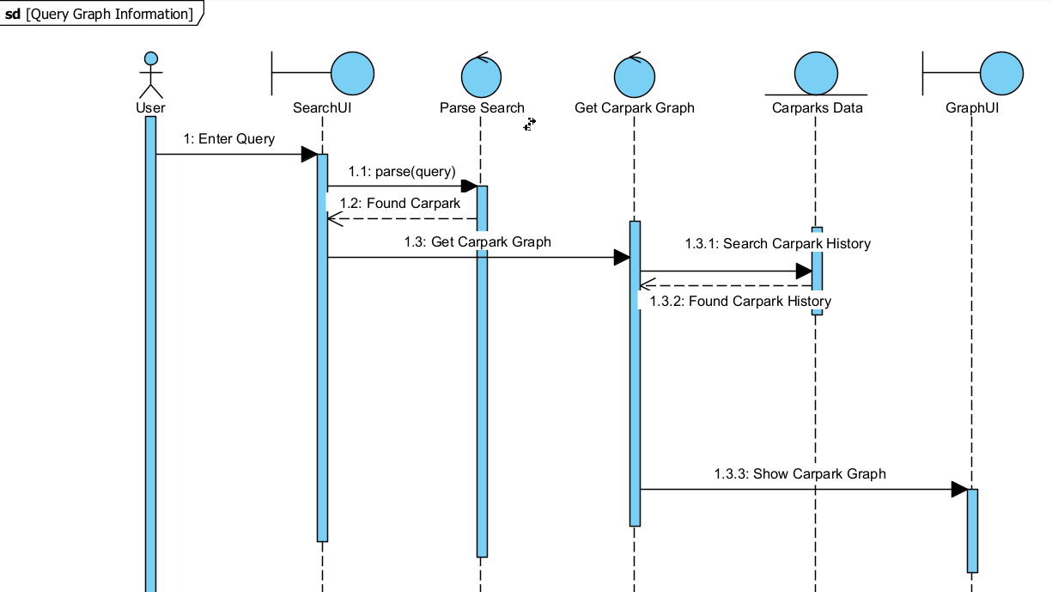

|  |  |  |  |
| --- | --- | --- | --- |
| Use Case ID: | 11 | | |
| Use Case Name: | Store History | | |
| Created By: | Joshua Adrian Cahyono | Last Updated By: | Joshua Adrian Cahyono |
| Date Created: | 7/2/2023 | Date Last Updated: | 7/2/2023 |
| Actor: | System, URA Carpark API, LTA Carpark API, data.gov.sg API, HDB Carpark Dataset | | |
| Description: | System stores the current availability of all the carparks | | |
| Preconditions: | 1. Server must be running 2. API must be working | | |
| Postconditions: | 1. Data is stored to the database | | |
| Priority: | Medium | | |
| Frequency of Use: | 10-12 times per hour | | |
| Flow of Events: | 1. System automatically requests API data of every carpark every 5 minutes. 2. API returns Basic availability of all the carparks 3. System stores the data to the server database | | |
| Alternative Flows: | - | | |
| Exceptions: | EX-1: Server is not running   1. No API will be called | | |
| Includes: | - | | |
| Special Requirements: | - | | |
| Assumptions: | 1. The APIs are working properly 2. The information is retrieved successfully from the database | | |
| Notes and Issues: | - | | |

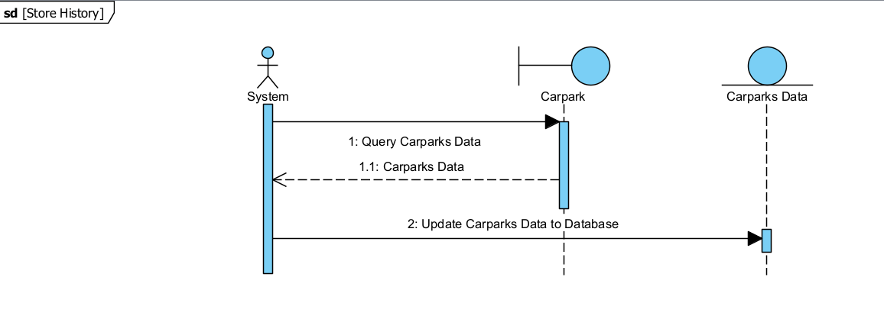

|  |  |  |  |
| --- | --- | --- | --- |
| Use Case ID: | 12 | | |
| Use Case Name: | Add/Remove Favorite List | | |
| Created By: | Joshua Adrian Cahyono | Last Updated By: | Joshua Adrian Cahyono |
| Date Created: | 7/2/2023 | Date Last Updated: | 7/2/2023 |
| Actor: | User, System | | |
| Description: | User can add or remove carparks to their favorite list. The chosen carparks will be prioritized when the user queries. | | |
| Preconditions: | 1. App must be connected to WiFi/Mobile Data 2. User must be logged in and authorized | | |
| Postconditions: | 1. Favorite list will be updated | | |
| Priority: | Low | | |
| Frequency of Use: | 0-5 times per hour | | |
| Flow of Events: | 1. User goes to the favorite tab 2. User search the carpark to remove it from the list 3. System will update the favorite list for that user | | |
| Alternative Flows: | AF-S1: User taps “Back” button while system is searching.   1. Return to step 1.   AF-S2b: Search query cannot be resolved to a carpark.   1. System returns error message.   AF-S4: User taps “Next Page” button   1. If there are more carpark listings, system repopulates search listing with next 10 (or other preset value) carpark listings, continue from step 3.   AF-S4: User taps “Previous Page” button   1. System repopulates search listing with previous 10 (or other preset value) carpark listings, continue from step 3. | | |
| Exceptions: | EX-AF-S1: Internet connection gets cut off   1. System displays error message “No internet connection, please check if your mobile data or Wifi is turned on.” 2. Return to step 1.   EX-AF-S2: User is not logged in   1. System displays message “You are not logged in yet” 2. System redirects the user to login page | | |
| Includes: | 1. Update User Personalization | | |
| Special Requirements: | - | | |
| Assumptions: | 1. Carpark list is retrieved successfully | | |
| Notes and Issues: | - | | |

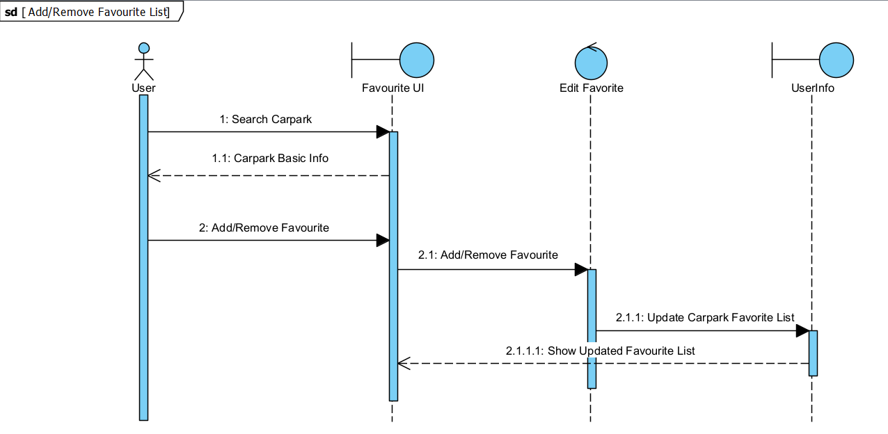

|  |  |  |  |
| --- | --- | --- | --- |
| Use Case ID: | 13 | | |
| Use Case Name: | Add/Remove Blacklist | | |
| Created By: | Joshua Adrian Cahyono | Last Updated By: | Joshua Adrian Cahyono |
| Date Created: | 7/2/2023 | Date Last Updated: | 7/2/2023 |
| Actor: | User, System | | |
| Description: | User can add or remove carparks to their blacklist. The chosen carparks will be hidden when the user queries. | | |
| Preconditions: | 1. App must be connected to WiFi/Mobile Data 2. User must be logged in and authorized | | |
| Postconditions: | 1. Blacklist will be updated | | |
| Priority: | Low | | |
| Frequency of Use: | 0-5 times per hour | | |
| Flow of Events: | 1. User goes to the blacklist tab 2. User search the carpark to add/remove it from the list 3. System will update the blacklist for that user | | |
| Alternative Flows: | AF-S1: User taps “Back” button while system is searching.   1. Return to step 1.   AF-S2a: User does not enter search query into search bar and commences search.   1. System assumes queried location to be current location.   AF-S2b: Search query cannot be resolved to a location.   1. System assumes queried location to be current location.   AF-S4: User taps “Next Page” button   1. If there are more carpark listings, system repopulates search listing with next 10 (or other preset value) carpark listings, continue from step 3.   AF-S4: User taps “Previous Page” button   1. System repopulates search listing with previous 10 (or other preset value) carpark listings, continue from step 3. | | |
| Exceptions: | EX-AF-S1: Internet connection gets cut off   1. System displays error message “No internet connection, please check if your mobile data or Wifi is turned on.” 2. Return to step 1.   EX-AF-S2: User is not logged in   1. System displays message “You are not logged in yet” 2. System redirects the user to login page | | |
| Includes: | 1. Update User Personalization | | |
| Special Requirements: | - | | |
| Assumptions: | 1. Carpark list is retrieved successfully | | |
| Notes and Issues: | - | | |

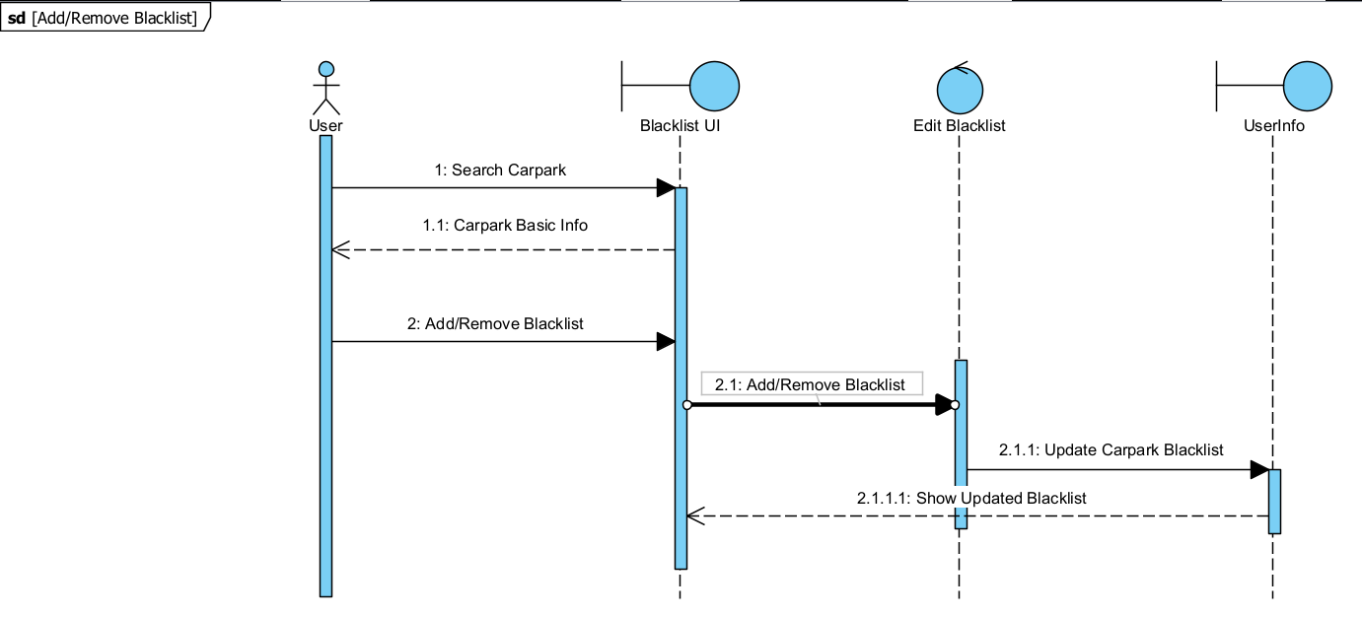

|  |  |  |  |
| --- | --- | --- | --- |
| Use Case ID: | 14 | | |
| Use Case Name: | Update User Personalization | | |
| Created By: | Joshua Adrian Cahyono | Last Updated By: | Joshua Adrian Cahyono |
| Date Created: | 7/2/2023 | Date Last Updated: | 7/2/2023 |
| Actor: | System | | |
| Description: | System updates user preferences | | |
| Preconditions: | 1. App must be connected to WiFi/Mobile Data 2. User must be logged in and authorized | | |
| Postconditions: | 1. Data will be updated | | |
| Priority: | Low | | |
| Frequency of Use: | 0-5 times per hour | | |
| Flow of Events: | 1. System accepts edit request from the user 2. System updates the data in the database | | |
| Alternative Flows: |  | | |
| Exceptions: | EX-AF-S1: Internet connection gets cut off   1. System displays error message “No internet connection, please check if your mobile data or Wifi is turned on.” 2. Return to step 1.   EX-AF-S2: User is not logged in   1. System displays message “You are not logged in yet” 2. System redirects the user to login page | | |
| Includes: | - | | |
| Special Requirements: | - | | |
| Assumptions: | - | | |
| Notes and Issues: | - | | |

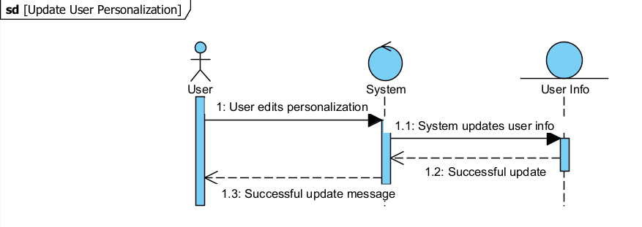

|  |  |  |  |
| --- | --- | --- | --- |
| Use Case ID: | 15 | | |
| Use Case Name: | Display Map | | |
| Created By: | Kenny Seah Yong Jie | Last Updated By: | Kenny Seah Yong Jie |
| Date Created: | 9/2/2023 | Date Last Updated: | 9/2/2023 |
| Actor: | System, User, OneMap API | | |
| Description: | Displays a map when the users request to display map of showing nearby carparks or when the 'Display Route between Addresses' use case is called when users request for navigation to a capark. | | |
| Preconditions: | 1. App must have an Internet Connection. 2. OneMap API must be online. 3. User must have logged in. 4. User has called one of the following use cases:    1. 'Display Map of Nearby Carparks'    2. 'Request Navigation to Carpark' | | |
| Postconditions: | 1. Map is successfully display on the viewport. | | |
| Priority: | High | | |
| Frequency of Use: | 0-10 times per day | | |
| Flow of Events: | 1. User calls one of the use cases under ‘Preconditions’.  * 1.1. 'Request Navigation of Carparks' calls upon the 'Display Route between Addresses' use case.  1. 'Display Map' sends request to OneMap API. 2. OneMap API responds with requested data. 3. Map is displayed on the viewport. | | |
| Alternative Flows: | AF-S1-S4: User taps “Back” button while ‘Display Map’ use-case is not done.   1. Cancel any request or wait for response. 2. Return to main menu.   AF-S1-S4: User exits App.   1. Cancel any request or wait for response..   AF-S1-S4: User switches to another App.   1. Cancel any request or wait for response. 2. Restart from previous step when user returns. | | |
| Exceptions: | EX-S3: OneMap API does not respond to request.   1. Determine if device has an internet connection. 2. If it does not, system displays error message “No internet connection, please check if your mobile data or Wifi is turned on.” 3. If it does, system displays error message "An error has occurred. Please try again later" | | |
| Includes: | - | | |
| Special Requirements: | - | | |
| Assumptions: | 1. Real-time Data from API accurately reflects real-time info. | | |
| Notes and Issues: | - | | |

|  |  |  |  |
| --- | --- | --- | --- |
| Use Case ID: | 16 | | |
| Use Case Name: | Convert Coordinates to Address | | |
| Created By: | Kenny Seah Yong Jie | Last Updated By: | Kenny Seah Yong Jie |
| Date Created: | 9/2/2023 | Date Last Updated: | 9/2/2023 |
| Actor: | System, User, OneMap API | | |
| Description: | Converts coordinates data to addresses when the 'Calculate Route between Addresses' use case is called upon when the user request for navigation to carpark. | | |
| Preconditions: | 1. App must have an Internet Connection. 2. OneMap API must be online. 3. User must have logged in. 4. User has called the 'Request Navigation to Carpark' use case. | | |
| Postconditions: | 1. System has received the address data provided by OneMap API response 2. Address data is being passed to the 'Calculate Route between Addresses' use case. | | |
| Priority: | High | | |
| Frequency of Use: | 0-10 times per day | | |
| Flow of Events: | 1. User calls the 'Request Navigation to Carpark' use case. 2. 'Request Navigation of Carparks' calls upon the 'Calculate Route between Addresses' use case. 3. 'Calculate Route between Addresses' calls upon the 'Convert Coordinates to Address' use case. 4. 'Convert Route between Addresses' sends request to OneMap API. 5. OneMap API responds with requested data. 6. Data is transferred back to 'Calculate Route between Addresses' use case. | | |
| Alternative Flows: | AF-S1-S6: User taps “Back” button while ‘Convert Coordinates to Address’ use-case is not done.   1. Cancel any request or wait for response. 2. Return to main menu.   AF-S1-S6: User exits App.   1. Cancel any request or wait for response..   AF-S1-S6: User switches to another App.   1. Cancel any request or wait for response. 2. Restart from previous step when user returns. | | |
| Exceptions: | EX-S5: OneMap API does not respond to request.   1. Determine if device has an internet connection. 2. If it does not, system displays error message “No internet connection, please check if your mobile data or Wifi is turned on.” 3. If it does, system displays error message "An error has occurred. Please try again later" | | |
| Includes: | - | | |
| Special Requirements: | - | | |
| Assumptions: | 1. Real-time Data from API accurately reflects real-time info. | | |
| Notes and Issues: | - | | |

|  |  |  |  |
| --- | --- | --- | --- |
| Use Case ID: | 17 | | |
| Use Case Name: | Calculate Route between Coordinates | | |
| Created By: | Kenny Seah Yong Jie | Last Updated By: | Kenny Seah Yong Jie |
| Date Created: | 9/2/2023 | Date Last Updated: | 9/2/2023 |
| Actor: | System, User, OneMap API | | |
| Description: | Calculates the routes between coordinates when the 'Calculate Route between Addresses' use case is called upon when the user request for navigation to carpark. | | |
| Preconditions: | 1. App must have an Internet Connection. 2. OneMap API must be online. 3. User must have logged in. 4. User has called the 'Request Navigation to Carpark' use case. | | |
| Postconditions: | 1. System has received the address data provided by OneMap API response 2. Address data is being passed to the 'Calculate Route between Addresses' use case. | | |
| Priority: | High | | |
| Frequency of Use: | 0-10 times per day | | |
| Flow of Events: | 1. User calls the 'Request Navigation to Carpark' use case. 2. 'Request Navigation of Carparks' calls upon the 'Calculate Route between Addresses' use case. 3. 'Calculate Route between Addresses' calls upon the 'Calculate Route between Coordinates' use case. 4. 'Convert Route between Coordinates' sends request to OneMap API. 5. OneMap API responds with requested data. 6. Data is transferred back to 'Calculate Route between Addresses' use case. | | |
| Alternative Flows: | AF-S1-S6: User taps “Back” button while ‘Calculate Route between Addresses’ use-case is not done.   1. Cancel any request or wait for response. 2. Return to main menu.   AF-S1-S6: User exits App.   1. Cancel any request or wait for response..   AF-S1-S6: User switches to another App.   1. Cancel any request or wait for response. 2. Restart from previous step when user returns. | | |
| Exceptions: | EX-S5: OneMap API does not respond to request.   1. Determine if device has an internet connection. 2. If it does not, system displays error message “No internet connection, please check if your mobile data or Wifi is turned on.” 3. If it does, system displays error message "An error has occurred. Please try again later" | | |
| Includes: | - | | |
| Special Requirements: | - | | |
| Assumptions: | 1. Real-time Data from API accurately reflects real-time info. | | |
| Notes and Issues: | - | | |

|  |  |  |  |
| --- | --- | --- | --- |
| Use Case ID: | 18 | | |
| Use Case Name: | Display Map of Nearby Carparks | | |
| Created By: | Kenny Seah Yong Jie | Last Updated By: | Kenny Seah Yong Jie |
| Date Created: | 9/2/2023 | Date Last Updated: | 9/2/2023 |
| Actor: | System, User, OneMap API | | |
| Description: | Displays map of carparks nearby target carpark on viewport. | | |
| Preconditions: | 1. App must have an Internet Connection. 2. OneMap API must be online. 3. User must have logged in. 4. User has clicked on the 'Show nearby Carparks' button. | | |
| Postconditions: | 1. Map of nearby carparks is displayed on viewport. | | |
| Priority: | High | | |
| Frequency of Use: | 0-10 times per day | | |
| Flow of Events: | 1. User clicks on the 'Show nearby Carparks' button. 2. 'Display Map of Nearby Carparks' calls upon the 'Display Map' use case. 3. 'Display Map' executes. 4. Map of nearby carparks is displayed on the viewport. | | |
| Alternative Flows: | AF-S1-S4: User taps “Back” button while ‘Display Map of Nearby Carparks’ use-case is not done.   1. Cancel any request or wait for response. 2. Return to main menu.   AF-S1-S4: User exits App.   1. Cancel any request or wait for response..   AF-S1-S4: User switches to another App.   1. Cancel any request or wait for response. 2. Restart from previous step when user returns. | | |
| Exceptions: | EX-S3: OneMap API does not respond to request.   1. Determine if device has an internet connection. 2. If it does not, system displays error message “No internet connection, please check if your mobile data or Wifi is turned on.” 3. If it does, system displays error message "An error has occurred. Please try again later" | | |
| Includes: | Display Map | | |
| Special Requirements: | - | | |
| Assumptions: | 1. Real-time Data from API accurately reflects real-time info. | | |
| Notes and Issues: | - | | |

|  |  |  |  |
| --- | --- | --- | --- |
| Use Case ID: | 19 | | |
| Use Case Name: | Display Route between Addresses | | |
| Created By: | Kenny Seah Yong Jie | Last Updated By: | Kenny Seah Yong Jie |
| Date Created: | 9/2/2023 | Date Last Updated: | 9/2/2023 |
| Actor: | System, User, OneMap API | | |
| Description: | Displays route between user location and target carpark on map on viewport. | | |
| Preconditions: | 1. App must have an Internet Connection. 2. OneMap API must be online. 3. User must have logged in. 4. User has called upon the 'Request Navigation to Carpark' use case. | | |
| Postconditions: | Route between user's current location to target carpark is displayed on map on viewport. | | |
| Priority: | High | | |
| Frequency of Use: | 0-10 times per day | | |
| Flow of Events: | 1. User calls upon the 'Request Navigation to Carpark' use case. 2. 'Request Navigation to Carpark' calls upon the 'Display Route between Addresses' use case. 3. 'Display Route between Addresses' calls upon the 'Display Map' use case. 4. 'Display Map' executes. 5. Map of nearby carparks is displayed on the viewport. | | |
| Alternative Flows: | AF-S1-S5: User taps “Back” button while ‘Display Route between Addresses’ use-case is not done.   1. Cancel any request or wait for response. 2. Return to main menu.   AF-S1-S5: User exits App.   1. Cancel any request or wait for response..   AF-S1-S5: User switches to another App.   1. Cancel any request or wait for response. 2. Restart from previous step when user returns. | | |
| Exceptions: | EX-S4: OneMap API does not respond to request.   1. Determine if device has an internet connection. 2. If it does not, system displays error message “No internet connection, please check if your mobile data or Wifi is turned on.” 3. If it does, system displays error message "An error has occurred. Please try again later" | | |
| Includes: | Display Map | | |
| Special Requirements: | - | | |
| Assumptions: | 1. Real-time Data from API accurately reflects real-time info. | | |
| Notes and Issues: | - | | |

|  |  |  |  |
| --- | --- | --- | --- |
| Use Case ID: | 20 | | |
| Use Case Name: | Calculate Route between Addresses | | |
| Created By: | Kenny Seah Yong Jie | Last Updated By: | Kenny Seah Yong Jie |
| Date Created: | 9/2/2023 | Date Last Updated: | 9/2/2023 |
| Actor: | System, User, OneMap API | | |
| Description: | Calculates the optimal route between user's current location and the target carpark. | | |
| Preconditions: | 1. App must have an Internet Connection. 2. OneMap API must be online. 3. User must have logged in. 4. User has called upon the 'Request Navigation to Carpark' use case. | | |
| Postconditions: | 1. Optimal route between user and target carpark, estimate travel time, and addresses's name  is obtained. 2. Data is passed to 'Request Navigation to Carpark' use case. | | |
| Priority: | High | | |
| Frequency of Use: | 0-10 times per day | | |
| Flow of Events: | 1. User calls upon the 'Request Navigation to Carpark' use case. 2. 'Request Navigation to Carpark' calls upon the 'Calculate Route between Addresses' use case. 3. 'Calculate Route between Addresses' calls upon the 'Convert Coordinates to Address' use case. 4. 'Convert Coordinates to Address' executes and return address data. 5. 'Calculate Route between Addresses' calls upon 'Calculate Route between Coordinates' use case. 6. Calculate Route between Coordinates' executes and return optimal route and estimated travel time. 7. Data is passed back to 'Request Navigation to Carpark' use case. | | |
| Alternative Flows: | AF-S1-S7: User taps “Back” button while ‘Calculate Route between Addresses’ use-case is not done.   1. Cancel any request or wait for response. 2. Return to main menu.   AF-S1-S7: User exits App.   1. Cancel any request or wait for response..   AF-S1-S7: User switches to another App.   1. Cancel any request or wait for response. 2. Restart from previous step when user returns. | | |
| Exceptions: | EX-S4/S6: OneMap API does not respond to request.   1. Determine if device has an internet connection. 2. If it does not, system displays error message “No internet connection, please check if your mobile data or Wifi is turned on.” 3. If it does, system displays error message "An error has occurred. Please try again later" | | |
| Includes: | Convert Coordinates to Address, Calculate Route between Coordinates | | |
| Special Requirements: | - | | |
| Assumptions: | 1. Real-time Data from API accurately reflects real-time info. | | |
| Notes and Issues: | - | | |

|  |  |  |  |
| --- | --- | --- | --- |
| Use Case ID: | 21 | | |
| Use Case Name: | Query Current Location | | |
| Created By: | Kenny Seah Yong Jie | Last Updated By: | Kenny Seah Yong Jie |
| Date Created: | 9/2/2023 | Date Last Updated: | 9/2/2023 |
| Actor: | System, User, OneMap API | | |
| Description: | Gets user's coordinates data from user system. | | |
| Preconditions: | 1. App must have an Internet Connection. 2. User must have logged in. 3. User has called upon the 'Request Navigation to Carpark' use case. | | |
| Postconditions: | 1. User's coordinates data is obtained. 2. User's coordinates data is passed to 'Request Navigation to Carpark' use case. | | |
| Priority: | High | | |
| Frequency of Use: | 0-10 times per day | | |
| Flow of Events: | 1. User calls upon the 'Request Navigation to Carpark' use case. 2. 'Request Navigation to Carpark' calls upon the 'Query Current Location' use case. 3. Check if GPS is turned on on user's system. 4. Get user's current coordinate data from system. 5. Return user's current coordinates data back to 'Request Navigation to Carpark' use case. | | |
| Alternative Flows: | AF-S1-S5: User taps “Back” button while ‘Query Current Location'’ use-case is not done.   1. Cancel any request or wait for response. 2. Return to main menu.   AF-S1-S5: User exits App.   1. Cancel any request or wait for response..   AF-S1-S5: User switches to another App.   1. Cancel any request or wait for response. 2. Restart from previous step when user returns.   AF-S3: GPS is not turned on:   1. Display message to prompt user to turn on GPS 2. Wait for user to click on 'Yes' or 'No' 3. If user clicked on 'No', return to main menu. 4. If user clicked on 'Yes, turn on GPS automatically and continue on step 4. | | |
| Exceptions: | EX-S4: Unable to get user's current coordinates data:   1. Determine if device has an internet connection and GPS is turned on. 2. If it does not, system displays error message “No internet connection, please check if your mobile data or Wifi is turned on.” 3. If it does, system displays error message "An error has occurred. Please try again later" | | |
| Includes: | - | | |
| Special Requirements: | - | | |
| Assumptions: | 1. Real-time Data from API accurately reflects real-time info. | | |
| Notes and Issues: | - | | |

|  |  |  |  |
| --- | --- | --- | --- |
| Use Case ID: | 22 | | |
| Use Case Name: | Request Navigation to Carpark | | |
| Created By: | Kenny Seah Yong Jie | Last Updated By: | Kenny Seah Yong Jie |
| Date Created: | 9/2/2023 | Date Last Updated: | 9/2/2023 |
| Actor: | System, User, OneMap API | | |
| Description: | Displays optimal route  between user's current location and target carpark, and estimated travel time. | | |
| Preconditions: | 1. App must have an Internet Connection. 2. OneMap API must be online. 3. User must have logged in. 4. User has clicked on the 'Navigate to Carpark' button. | | |
| Postconditions: | Optimal route  between user's current location and target carpark, and estimated travel time is displayed on viewport. | | |
| Priority: | High | | |
| Frequency of Use: | 0-10 times per day | | |
| Flow of Events: | 1. User clicks on 'Navigate to Carpark' button. 2. 'Request Navigation to Carpark' calls upon 'Query Current Location' use case. 3. 'Query Current Location' executes and returns user's coordinates data. 4. 'Request Navigation to Carpark' calls upon 'Calculate Route between Addresses' use case. 5. 'Calculate Route between Addresses' executes and returns optimal route and estimated travel time data. 6. 'Request Navigation to Carpark' calls upon 'Display Route between Addresses' use case. 7. 'Display Route between Addresses' executes and displays map. 8. Estimated travel time is printed on the screen. | | |
| Alternative Flows: | AF-S1-S8: User taps “Back” button while ‘Request Navigation to Carpark'’ use-case is not done.   1. Cancel any request or wait for response. 2. Return to main menu.   AF-S1-S8: User exits App.   1. Cancel any request or wait for response..   AF-S1-S8: User switches to another App.   1. Cancel any request or wait for response. 2. Restart from previous step when user returns. | | |
| Exceptions: | EX-S3/S5/S7: Included use case fails to execute to completion:   1. Determine if device has an internet connection and GPS is turned on. 2. If it does not, system displays error message “No internet connection, please check if your mobile data or Wifi is turned on.” 3. If it does, system displays error message "An error has occurred. Please try again later" | | |
| Includes: | Query Current Address, Display Route between Addresses, Calculate Route between Addresses | | |
| Special Requirements: | - | | |
| Assumptions: | 1. Real-time Data from API accurately reflects real-time info. | | |
| Notes and Issues: | - | | |

# UI Mockups

